**LAB Assignment#02**

***Subject:***

***MAD***

**Submitted By**

**Saleem Ahmed FA19-BCS-100**

**Submitted to**

**Sir Muhammad Kamran**

***COMSATS University Islamabad***

***Attock Campus***

**Design the screen:**

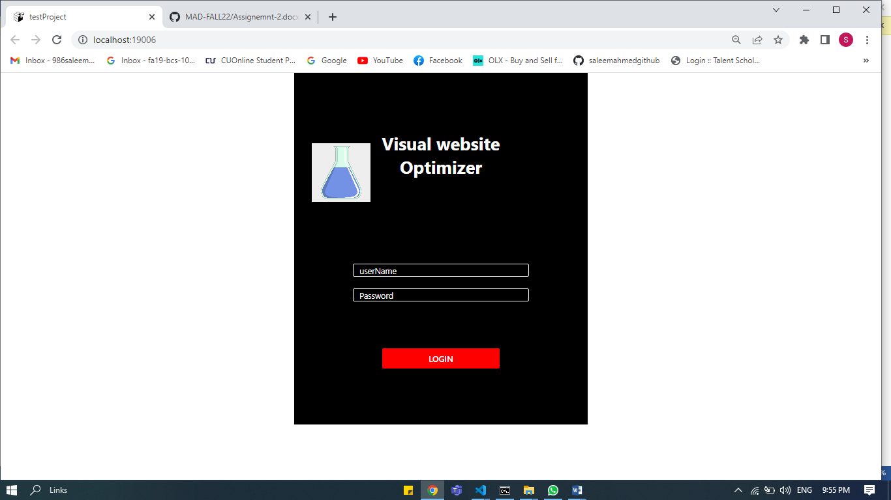

Link:

<https://www.pinterest.com/pin/337418197056192602/?mt=login>

